IMPLEMENTING WEB APPLICATION CREATING UI TO INTERACT WITH APPLICATION

|  |  |
| --- | --- |
| Team ID | PNT2022TMID17805 |
| Project Name | Plasma Donor Application |

# Login Page:

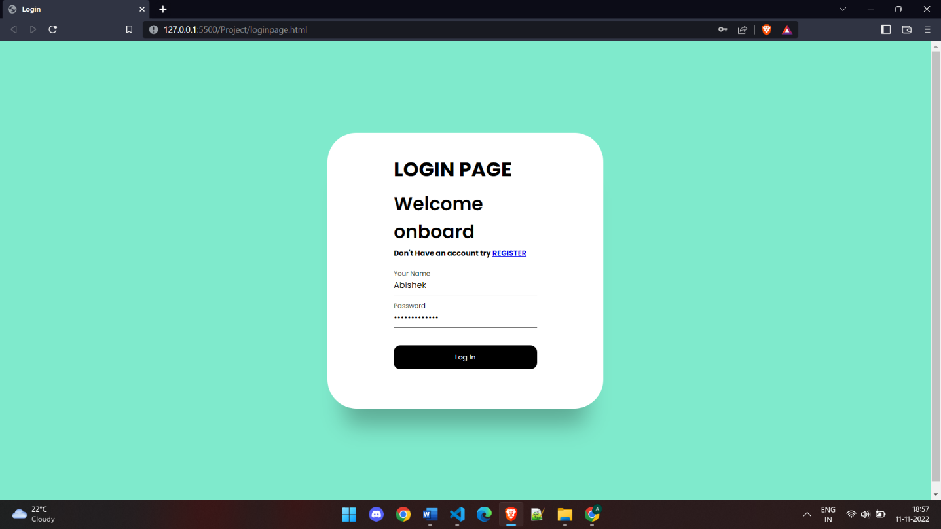

**Registeration Page:**

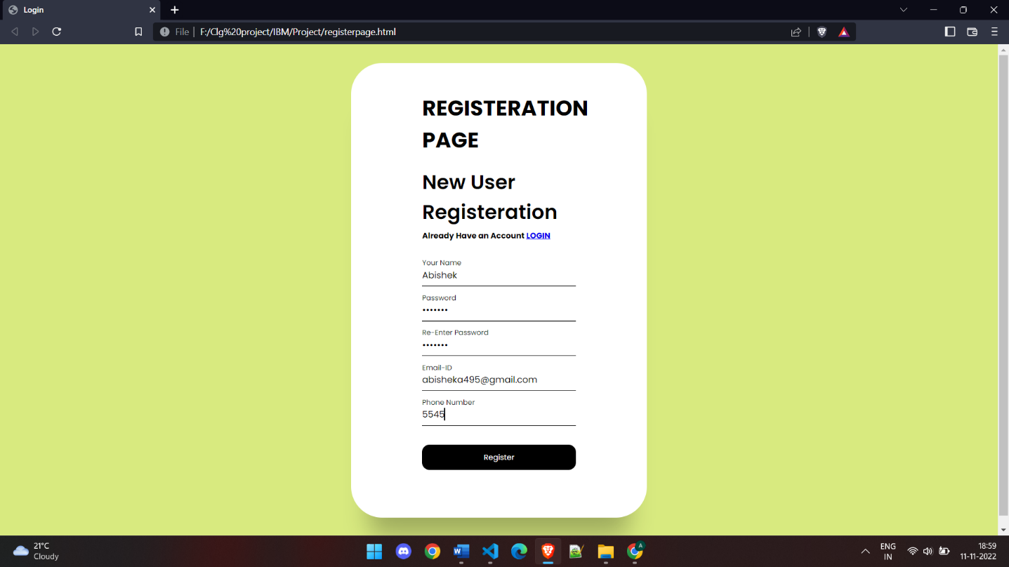

# Loginpage.html

<!DOCTYPE html>

<html lang="en">

<head>

<meta charset="UTF-8" />

<meta http-equiv="X-UA-Compatible" content="IE=edge" />

<meta name="viewport" content="width=device-width, initial-scale=1.0" />

<title>Login</title>

<style> @import

url(["https://fonts.googleapis.com/css2?family=Poppins:wght@200;300;400;](https://fonts.googleapis.com/css2?family=Poppins%3Awght%40200%3B300%3B400%3B) 500;600;700;800&display=swap");

*,

*::before,

*::after { padding: 0;

margin: 0;

box-sizing: border-box;

}

body, input {

font-family: "Poppins", sans-serif;

}

main {

width: 100%;

min-height: 100vh; overflow: hidden; background-color: #7feacc; padding: 2rem;

display: flex;

align-items: center; justify-content: center;

}

.box {

position: relative; width: 100%;

max-width: 500px; height: 500px; background-color: #fff; border-radius: 3.3rem;

box-shadow: 0 60px 40px -30px rgba(0, 0, 0, 0.27);

}

.forms-wrap { position: absolute; height: 100%; display: grid;

grid-template-columns: 1fr; margin-left: 120px;

grid-template-rows: 1fr;

}

form {

max-width: 260px; width: 100%;

height: 100%; display: flex;

flex-direction: column; justify-content: space-evenly;

}

form.sign-up-form { opacity: 0;

pointer-events: none;

}

.logo {

display: flex;

align-items: center; font-size:x-large; color: #000000;

}

.heading h2 {

font-size: 2.1rem; font-weight: 600; color: black;

margin-top: -30px; margin-bottom: 5px;

}

.heading h6 { color: #333133;

font-weight: 400; font-size: 0.75rem; display: inline;

}

.input-wrap { position: relative; height: 37px;

margin-bottom: 2rem; margin-top: -10px;

}

.input-field { position: absolute; width: 100%;

height: 100%; background: none; border: none; outline: none;

border-bottom: 1px solid rgb(69, 63, 72);

padding: 0;

font-size: 0.95rem; color: #000000; transition: 0.4s;

}

label {

position: absolute; left: 0;

top: 50%;

transform: translateY(-50%); font-size: 0.95rem;

color: rgb(34, 29, 37); pointer-events: none; transition: 0.4s;

}

.input-field.active {

border-bottom-color: #000000;

}

.input-field.active + label { font-size: 0.75rem;

top: -2px;

}

.sign-btn {

display: inline-block; width: 100%;

height: 43px;

background-color: #000000; color: #fff;

border: none; cursor: pointer;

border-radius: 0.8rem; font-size: 0.8rem; margin-bottom: 2rem; transition: 0.3s;

}

.sign-btn:hover {

background-color: #8371fd;

}

@media (max-width: 850px) {

.box {

height: auto;

max-width: 550px; overflow: hidden;

}

.inner-box { position: static; transform: none;

width: revert; height: revert; padding: 2rem;

}

.forms-wrap { position: revert; width: 100%; height: auto;

}

form {

max-width: revert;

padding: 1.5rem 2.5rem 2rem;

transition: transform 0.8s ease-in-out, opacity 0.45s linear;

}

.heading { margin: 2rem 0;

}

@media (max-width: 530px) { main {

padding: 1rem;

}

.box {

border-radius: 2rem;

}

.inner-box { padding: 1rem;

}

.carousel {

padding: 1.5rem 1rem; border-radius: 1.6rem;

}

.text-wrap {

margin-bottom: 1rem;

}

.text-group h2 { font-size: 1.2rem;

}

form {

padding: 1rem 2rem 1.5rem;

}

}

</style>

</head>

<body>

<main>

<div class="box">

<div class="forms-wrap">

<form action="index.html" autocomplete="off" class="sign-in-form">

<div class="logo">

<h2>LOGIN PAGE</h2>

</div>

<div class="heading">

<h2>Welcome onboard</h2>

<h5>Don't Have an account try

<a href="#" class="toggle">REGISTER</a></h5>

</div>

<div class="actual-form">

<div class="input-wrap">

<input

type="text" minlength="4" class="input-field" autocomplete="off" required

/>

<label>Your Name</label>

</div>

<div class="input-wrap">

<input

type="password" minlength="4" class="input-field" autocomplete="off" required

/>

<label>Password</label>

</div>

<input type="submit" value="Log In" class="sign-btn" />

</form>

</div>

</div>

</main>

<h6 style="text-align:center;">Plasma Donor Application by TeamID : PNT2022TMID17803</h6>

<script>const inputs = document.querySelectorAll(".input-field");

inputs.forEach((inp) => { inp.addEventListener("focus", () => {

inp.classList.add("active");

});

inp.addEventListener("blur", () => { if (inp.value != "") return; inp.classList.remove("active");

});

});

</script>

</body>

</html>

# Regiterationpage.html

<!DOCTYPE html>

<html lang="en">

<head>

<meta charset="UTF-8" />

<meta http-equiv="X-UA-Compatible" content="IE=edge" />

<meta name="viewport" content="width=device-width, initial-scale=1.0" />

<title>Login</title>

<style> @import

url(["https://fonts.googleapis.com/css2?family=Poppins:wght@200;300;400;](https://fonts.googleapis.com/css2?family=Poppins%3Awght%40200%3B300%3B400%3B) 500;600;700;800&display=swap");

*,

*::before,

*::after {

padding: 0;

margin: 0;

box-sizing: border-box;

}

body, input {

font-family: "Poppins", sans-serif;

}

main {

width: 100%;

min-height: 100vh; overflow: hidden; background-color: #d8ea7f; padding: 2rem;

display: flex;

align-items: center; justify-content: center;

}

.box {

position: relative; width: 100%;

max-width: 500px; height: 770px; background-color: #fff; border-radius: 3.3rem;

box-shadow: 0 60px 40px -30px rgba(0, 0, 0, 0.27);

}

.forms-wrap {

position: absolute; height: 100%; display: grid;

grid-template-columns: 1fr; margin-left: 120px;

grid-template-rows: 1fr;

}

form {

max-width: 260px; width: 100%;

height: 100%; display: flex;

flex-direction: column; justify-content: space-evenly;

}

form.sign-up-form { opacity: 0;

pointer-events: none;

}

.logo {

display: flex;

align-items: center; font-size:x-large; color: #000000;

}

.heading h2 {

font-size: 2.1rem; font-weight: 600; color: black;

margin-top: -30px; margin-bottom: 5px;

}

.heading h6 { color: #333133;

font-weight: 400; font-size: 0.75rem; display: inline;

}

.input-wrap { position: relative; height: 37px;

margin-bottom: 2rem; margin-top: -10px;

}

.input-field { position: absolute; width: 100%;

height: 100%; background: none; border: none; outline: none;

border-bottom: 1px solid rgb(69, 63, 72);

padding: 0;

font-size: 0.95rem; color: #000000; transition: 0.4s;

}

label {

position: absolute; left: 0;

top: 50%;

transform: translateY(-50%); font-size: 0.95rem;

color: rgb(34, 29, 37); pointer-events: none; transition: 0.4s;

}

.input-field.active {

border-bottom-color: #000000;

}

.input-field.active + label { font-size: 0.75rem;

top: -2px;

}

.sign-btn {

display: inline-block; width: 100%;

height: 43px;

background-color: #000000; color: #fff;

border: none; cursor: pointer;

border-radius: 0.8rem; font-size: 0.8rem; margin-bottom: 2rem; transition: 0.3s;

}

.sign-btn:hover {

background-color: #8371fd;

}

@media (max-width: 850px) {

.box {

height: auto;

max-width: 550px; overflow: hidden;

}

.inner-box { position: static; transform: none; width: revert; height: revert; padding: 2rem;

}

.forms-wrap { position: revert; width: 100%; height: auto;

}

form {

max-width: revert;

padding: 1.5rem 2.5rem 2rem;

transition: transform 0.8s ease-in-out, opacity 0.45s linear;

}

.heading { margin: 2rem 0;

}

@media (max-width: 530px) { main {

padding: 1rem;

}

.box {

border-radius: 2rem;

}

.inner-box { padding: 1rem;

}

.carousel {

padding: 1.5rem 1rem; border-radius: 1.6rem;

}

.text-wrap {

margin-bottom: 1rem;

}

.text-group h2 { font-size: 1.2rem;

}

form {

padding: 1rem 2rem 1.5rem;

}

}

</style>

</head>

<body>

<main>

<div class="box">

<div class="forms-wrap">

<form action="index.html" autocomplete="off" class="sign-in-form">

<div class="logo">

<h2>REGISTERATION PAGE</h2>

</div>

<div class="heading">

<h2>New User Registeration</h2>

<h5>Already Have an Account

<a href="#" class="toggle">LOGIN</a></h5>

</div>

<div class="actual-form">

<div class="input-wrap">

<input

type="text" minlength="4" class="input-field" autocomplete="off" required

/>

<label>Your Name</label>

</div>

<div class="input-wrap">

<input

type="password" minlength="4" class="input-field" autocomplete="off" required

/>

<label>Password</label>

</div>

<div class="input-wrap">

<input

type="password" minlength="4" class="input-field" autocomplete="off" required

/>

<label>Re-Enter Password</label>

</div>

<div class="input-wrap">

<input

type="text" minlength="4" class="input-field" autocomplete="off" required

/>

<label>Email-ID</label>

</div>

<div class="input-wrap">

<input

type="text" minlength="4" class="input-field" autocomplete="off" required

/>

<label>Phone Number</label>

</div>

<input type="submit" value="Register" class="sign-btn"

/>

</form>

</div>

</div>

</main>

<h6 style="text-align:center;">Plasma Donor Application by TeamID : PNT2022TMID17805</h6>

<script>const inputs = document.querySelectorAll(".input-field");

inputs.forEach((inp) => { inp.addEventListener("focus", () => {

inp.classList.add("active");

});

inp.addEventListener("blur", () => { if (inp.value != "") return; inp.classList.remove("active");

});

});

</script>

</body>

</html>